Information for applicants

Extract from University of Derby’s Professorial Handbook

Introduction
The title of Professor may be conferred upon persons who hold an appointment in a substantive Professorial level role, or in such other role as is deemed by the University Executive to be at an equivalent level. The appointment may be full time or fractional. Professorial title is recognition of the individual’s academic authority, demonstrated in accordance with the established criteria and confirmed by internal and external peer judgement. A professorship may be sponsored, in which case the sponsor's name will normally be part of the title.

Criteria for the award of the title of Professor
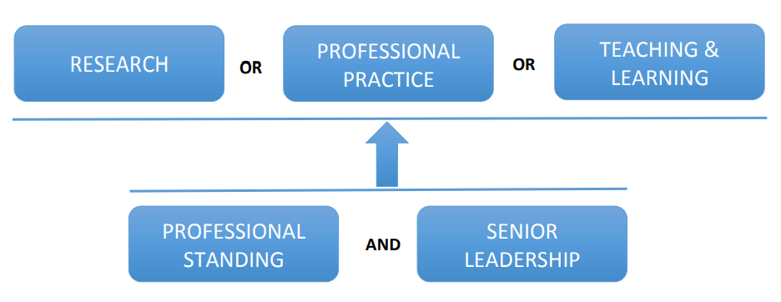
In order to meet the Professorial criteria, applicants will need to demonstrate proven achievement against two criteria:
- Outstanding achievement in
- Research or
- Professional Practice or
- Teaching and Learning
And must also demonstrate
- Very high level of achievement in relation to both
- Professional Standing and
- Senior Leadership
Research: Generation of visible national/international impact to an academic discipline through the established record of authorship or creation of research outputs (publications, patents, software, artistic works and others) that lead to new knowledge or practices and are recognised by peers as being of high quality. Evidence of ability to deliver income generation through research and/or commercial activities.
Professional Practice: Generation of visible national/international impact to business/industry through an established record of successful applications for funding to support enterprise, research or commercial activities; successful collaborations with external partners in industry, commerce and the public sector; successful delivery of new or enhanced and sustainable income streams.
Teaching & Learning: Generation of visible national/international impact to the experience & achievement of students through an established record of pedagogic innovation and/or the scholarship of teaching and learning that leads to new knowledge or practices and is recognised by peers as being of high quality.
Professional Standing: External indicators of the applicant’s reputation and standing in the field in the context of research, teaching & learning or enterprise, through: professional and or industry/business recognition, citizenship and contribution to society, membership of significant national and or international committees and boards; awards and prizes, honorary and visiting titles; other engagements that evidence the high external reputation of the individual.
Senior Leadership:
Research: management and leadership of individuals and research groups; experience in the supervision of doctoral research, including as first supervisor; leadership in Research Excellence Framework; evidence of leadership roles in the dissemination of knowledge.
Teaching & learning: management and leadership of individuals and groups in the enhancement of pedagogic practice; leadership in Teaching Excellence Framework; evidence of the dissemination of innovative teaching practices and the impact of this.
Professional Practice: management and leadership of individuals and groups in the delivery of enterprise projects; initiation of new enterprise projects and successful management of those projects to delivery; evidence of leadership roles in the dissemination of knowledge.
All: Contribution to the development, implementation and evolution of university or industry strategic plans; evidence of impact in supporting the development of others to enable them to deliver in the relevant context.

Documentation required
Applicants will be expected to apply for the role through the University’s recruitment process and provide the following documentation:
- An up to date current curriculum vitae;
- A supporting covering letter outlining your suitability to the underlying role requirement, and;
- The names of two employment referees (including ideally, the last line manager).
In addition, in order to meet the Professorial criteria, you will need to provide:
- A written statement evidencing how you meet the criteria for the award of the title of Professor;
- Details of four appropriately qualified referees (of at least Professor status) in relation to the Professorial title.
Further information in relation to both (iv) and (v) is set out below.

Requirements in respect of the written statement in support of Professorial title
Evidencing the categories: The statement needs to clearly identify the criterion in which the requirement for outstanding achievement is met. The category descriptors in the Professorial criteria describe the widest interpretation of the terms research, professional practice, teaching & learning, professional standing and senior leadership. The individual’s achievements must be supported by evidence in the public domain and corroborated by external peer review.
Peer review: The underlying principle in assessing applications from candidates for the award of title of Professor will be that of peer review. Academic achievements that are tangible and are recognised on a national or international scale will normally carry more weight than small scale or purely local initiatives. Staff with an international reputation may represent a case that rests on a relatively narrow range of activities.
Supplementary materials: The submission of supplementary materials is normally unnecessary and is discouraged. However, applicants for professorships on the basis of professional practice and teaching & Learning may submit carefully compiled documentation which evidences achievement that is not otherwise supported. Any supplementary material should be kept to the absolute minimum necessary.
Clarity of expression: Statements in support of the professorial title should be clear, cogent and well presented. It should be accurate, informative and written to a high standard of English.
Citation:
- The statement will normally need to cite published works in support of the case. These may include papers published in journals, conference papers, chapters in research volumes, student text books, general books, special reports, monographs, catalogues and reviews.
- Artists may wish to cite public exhibitions which they have organised and other forms of creative works.
- In the case of jointly published key papers, candidates are strongly advised to ensure that they annotate the citation indicating the status of the journal, whether the paper was refereed and explain clearly their part in the joint research and the significance of the findings.
- The simple listing of works under these categories is not sufficient. Candidates are advised to group their publications in suitable categories such as research papers, special reports, conference papers, books, reviews. Artists are requested to group solo exhibitions and other exhibitions to which they have contributed.

Requirements in respect of referees
The candidate should provide the names, addresses and email addresses of four Professorial referees.
- Impartiality: Impartiality is very important. The referees should be external to the institution and independent in the sense that they have not collaborated with the applicant on research or scholarship or consultancy projects in the last five years. It is also inadvisable for the candidate to cite the former supervisor of their doctoral thesis.
- Status: The referees should normally hold a Professorship in a discipline related to the field of work pursued by the applicant. However, occasionally it may be appropriate to cite as a referee a distinguished individual in the field who does not hold a Professorship.
- Communication with the referee: The candidate does not need to be personally acquainted with the referees and does not need to approach the referees in advance. The University will assume that the candidate has not approached the referees.
Note: In addition to the four referees nominated by the applicant, the Dean will be asked to nominate one additional independent external referee. Thus there will be five referees altogether (plus two employment references).

Note on terminology:
- Independent is taken to mean that the candidate and the referee have not collaborated significantly in the past and have not engaged in joint works at all in the last five years.
- External means external to the institution(s) where the candidate has worked in the last five years.
- Meaning of “appropriately qualified”: referees should be impartial and should have suitable status to deliver the element of peer review.
- Impartiality: Impartiality is very important. The referees should be external to the institution and independent in the sense that they have not collaborated with the applicant on research or scholarship or consultancy projects in the last five years. It is also inadvisable for the candidate to cite the former supervisor of their doctoral thesis.
- Status: The referees should normally hold a professorship in a discipline related to the field of work pursued by the applicant. However, occasionally it may be appropriate to cite as a referee a distinguished individual in the field who does not hold a professorship.

