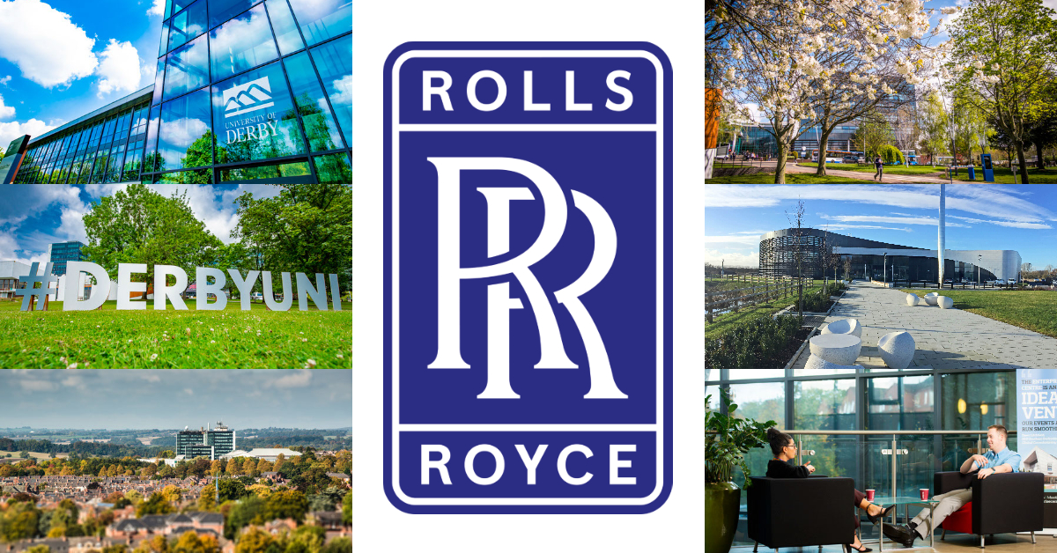
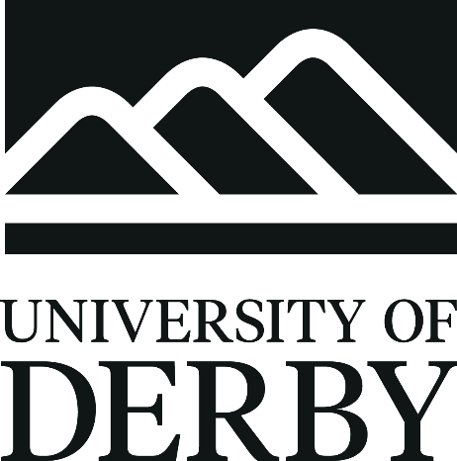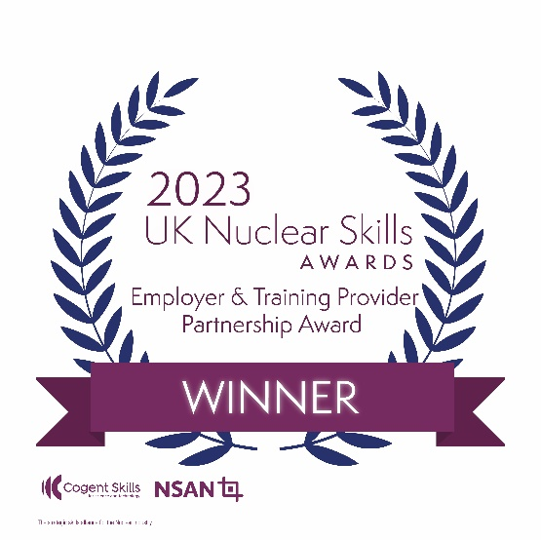

About the Academy

The Nuclear Skills Academy is the first of its kind anywhere and aims to sustain nuclear capability within the UK’s submarines programme by creating a dedicated pipeline of talent at the start of their careers.

Based in Derby at Infinity Park Derby, the award–winning Nuclear Skills Academy is a partnership between the University of Derby and Rolls-Royce supported by industry and education experts, including the Nuclear Advanced Manufacturing Research Centre, the National College for Nuclear and Derby City Council. This ensures new apprentices have access to the best courses and industrial mentors throughout their apprenticeship. Rolls-Royce has supplied the power for all the Royal Navy’s nuclear submarines from its base in Derby for 60 years. Their work ensures submariners can continuously protect the UK’s interests at home and further afield 24 hours a day, 365 days a year.

The academy welcomed its first cohort of 200 apprentices in September last year and the university’s leadership of this successful academy means it is growing. The Nuclear Skills Academy will provide 200 apprentices each year, across a variety of nuclear-focussed courses, with an industry-leading nuclear education. The support of key industry organisations in driving the project forward has been crucial for Rolls-Royce. The apprenticeships are spread across all functions of the business including Engineering, Manufacturing and Business. They provide fully funded, further and higher education qualifications, while the apprentices receive hands-on practical work experience within this exciting, and growing, global business.

Each of the courses are delivered by the University of Derby and endorsed by the National College for Nuclear.

The university leads the nuclear apprenticeship pathways, and we have worked to develop the academy and implemented the highest quality classroom and digital learning spaces, along with industry-standard engineering workshops.

As a result of the impact and significance of the Nuclear Skills Academy, we were delighted to win the Employer & Training Provider Partnership Award at the UK Nuclear Skills Awards 2023 held in Manchester, in partnership with Rolls-Royce Submarines Ltd.

To find out more about the current roles available, please see: https://www.derby.ac.uk/jobs/current-vacancies/



Why come and work with us:

As well as being at the forefront of the nuclear industry and supporting the future talent pipelines, you will be employed by the University of Derby. We are proud of our staff and understand that the best student experience can only be delivered if the people we have working for us share our vision, our ambitions, and our dedication to delivering excellence. We understand the importance of high-quality staff experience to get the best out of people in a high-performance culture, where we strive to compete with the best in our sector.

Our values were shaped by our staff and provide the foundation for our future success as ‘an applied university of today and for tomorrow.’ Our values - Values people, Bold, Future-Focused and Brilliance, reflect our strong sense of purpose, confidence, and desire to succeed and we believe it is these values that make Derby a great place to work and study. You can learn more about our values on the University website.

The University of Derby Strategic Framework 2018-2030 was developed in consultation with our staff, our students and our stakeholders and reflections the ambitions of the university which continue to grow. Key to the success of the framework and at the heart of all we do are our people.

As well as competitive salaries, we appreciate the importance of a healthy work/life balance and are therefore able to offer a benefits package that includes generous holiday entitlements and fantastic retirement provisions.

Those in academic roles receive 35 days annual leave per year, middle and senior management receive 30 days and all other roles including technical, administrative, and supervisory receive 26 days. On top of this, all staff also receive bank holidays and 4 University days around Christmas and Easter.

All eligible staff can join a defined benefit pension (Teacher’s Pension Scheme for academics and Local Government Pension Scheme for all other eligible staff), this provides you with a retirement income based on your salary and the number of years you have worked for the university. This pension scheme pays you a secure income for life, which increases each year and provides life cover.

Our middle and senior management can access additional flexible benefits such as holiday trading, dental plans, and private medical insurance.

Valuing people is a cornerstone of our values, hence we offer a range of family-friendly polices such as maternity, paternity, leave special circumstances such as serious family illness and bereavement.

As an education institution, we have numerous training and development opportunities available to all staff to support their continuing professional development. We hold regular in-house training sessions to help our staff develop skills in everything from managing their time to brushing up on their Microsoft Office skills.

You can also study whilst you work and gain the technical knowledge, practical experience, and wider skills you need for your future career through our Staff Apprenticeship Scheme. We also offer discounted tuition fees for our degree and postgraduate programmes of study for employee and family.

We also offer a comprehensive blended induction approach to new starters. Our face-to-face welcome events to the organisation are run every 6 weeks. This experience brings to life our values and helps colleagues understand what it means to be part of the University of Derby community.

Those in leadership roles, benefit from a leadership induction, helping them understand our governance and conditions of registration, their role in delivering on our ambitions and building an inclusive and high-performance culture. This is further supported by an online one-stop leadership resource for new leaders and specific leadership online learning modules on topics such as appraisals and health and safety.

